Final Project Report

**Traffic Sign Detection**

August6th, 2023

**GROUP 3**

Thien An Trinh

Roman Burekhin

Athira Devan

Lester Azinge

# INTRODUCTION

We are living in a world that is moving towards automation. From robot arms assembling individual components into complete cars to smart household appliances that have been transforming our homes, the benefits of autonomous applications are undeniable. The automobile industry is following the same trend. Not only autopilot systems assist drivers by bringing them better driving experience, but they can also help reduce the number of accidents. For example, a vehicle with a smart traffic sign detection system can “see” all the signs ahead including those the driver could miss, and thereby perform proper actions timely in time-sensitive situation.

In that context, our project focused two paramount objectives: first, to meticulously benchmark a range of model architectures to identify the most optimal and efficient solution for this challenging task, and second, to deploy and demonstrate precise and reliable detection of critical traffic signs.

Before proceeding into further detail, it is crucial to address certain concepts related to how the task was framed. First of all, it was determined that the project is a computer vision task – a domain in which images are processed and analyzed in order to extract useful information that can drive decision-making (Arabnia et al., 2018; Yoshida, 2011). Second, within the computer vision domain, this project is specifically an *object detection* task where an image was analyzed not for obtaining the semantic meaning of the whole image (i.e., *image classification*), or for segmenting the image into meaningful regions (i.e., *image segmentation*), but rather to identify targeted objects that are present in the images and determine where on the images they are located. In this project, the objects of interest were *traffic lights, stop signs, speed limit signs* and *crosswalk signs*, which are the fundamental elements that guide drivers and traffic flow. Third, the algorithms required for this task were defined to be deep learning (DL) convolutional neural networks (CNNs) which has always been the state-of-the-art in the domain for a decade. Furthermore, the project also leveraged an advanced DL technique called *transfer learning*, in which neural networks that were pretrained on a large dataset are fine-tuned on the dataset of interest instead of being trained from scratch, and therefore are capable of attaining high evaluation scores in the new domain. The details of the data, pretrained-models, training and evaluation frameworks are now discussed in the following section.

# METHODOLOGY

## Data

### Data Source

The data for this project was from Kaggle and is available at this reference (*Road Sign Detection*). The dataset comprises of two folders, each of which consists of 877 files. The first folder is named “*images*” which contains 877 road sign images in PNG, whereas the other is named “*annotations*” and has 877 corresponding XML files that store the image annotations in the PASCAL VOC format (Everingham et al., 2015). The images belong to 4 distinct classes, namely *traffic light, stop, speed limit,* and *crosswalk* which are the target objects to detect (Figure 1, Figure 2).



Figure 1. Sample Images from the Dataset (obtained via (Road Sign Detection))

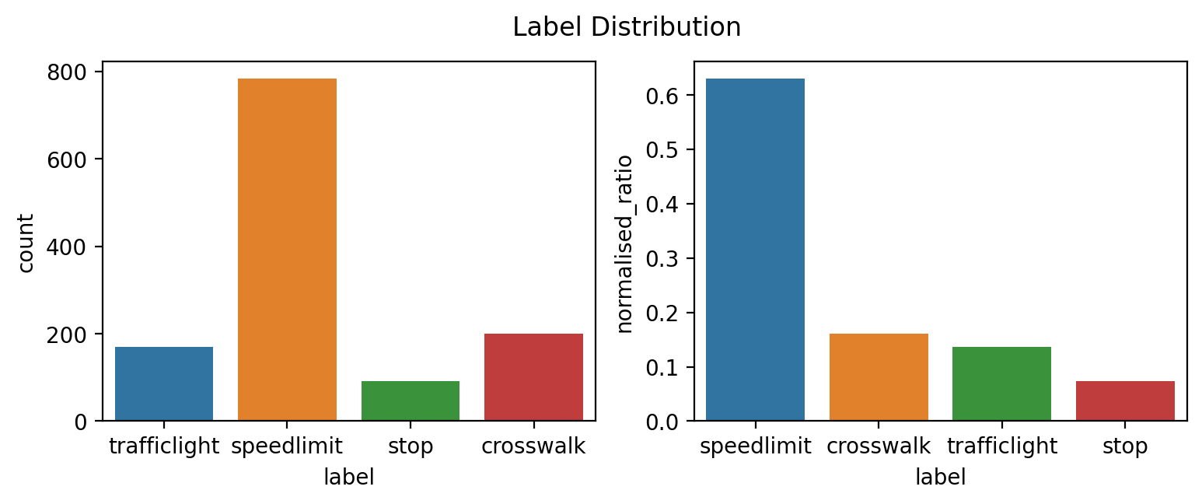

Figure 2. Distribution of Object Classes in the Dataset

### Data Preprocessing

#### The data was split into a training and a validation set with the ratio of 4:1. As a result, the training set contained 701 images and the validation set had 176. Additionally, since the original format of the annotations were not ready to be used in the training pipeline, label format conversion was performed. Since the models used in the experiments required two different training frameworks, there were two types of conversion. The first framework was the TensorFlow object detection API which required the annotations in TFRecord format, while the Ultralytics framework for YOLOv5 expected the annotations in text format with each line describing the bounding boxes of the objects. More details of the frameworks are discussed in Section 2.2. It is notable that the training and validation sets had separate annotation conversion, so that resulting files were distinctly addressed in the training configuration to be the training and validation annotations respectively. Further details of the data preprocessing steps can be found in the Jupyter notebooks.

### Data Augmentation

Data augmentation is a technique that helps diversify the training data by adding variations to the images. For fair benchmarking and evaluation, similar augmentations had to be used in both frameworks (e.g., if the TensorFlow models used shearing at 30o, YOLOv5 had to use the same transformation), meaning that we could only choose the augmentation options that were available in both frameworks. Additionally, in the context of traffic sign detection, some transformations would not be applicable such as vertical or horizontal flips, or 90o rotation. Due to these requirements, there were a limited number of options available that could be utilized. In this project, we could select only one augmentation option that fitted the situation, and it was image scaling (Figure 3, Figure 4). Nevertheless, this single augmentation proved to be effective as described in detail in a later section of this report.

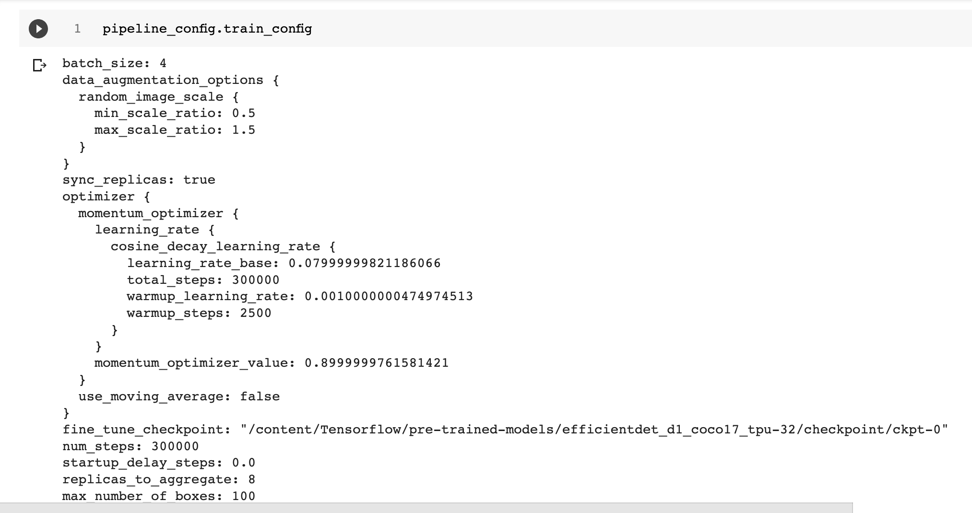

Figure 3. Data Augmentation Configuration for the TensorFlow Framework

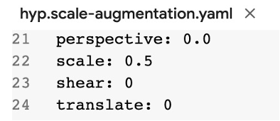

Figure 4. Data Augmentation Configuration for the YOLOv5 Framework

## Models and Frameworks

As the objective of this project was to develop a working app, it was important to diversify the models in the experiment phase in order to discover the optimal one for deployment. Considering the CNNs in the field of object detection, these following architectures stood out as the state-of-the-art.

### Single Shot MultiBox Detector (SSD)

The Single Shot MultiBox Detector was firstly introduced in 2015 (Liu et al., 2015). This CNN architecture employs a set of default boxes of various aspect ratios and scales which, upon inference, can be adjusted to match the object shapes for better detection. Moreover, to cope with objects of different sizes, it leverages the fact that different feature maps have different resolutions, and therefore uses multiple predictions from these layers to compute the final detections. Figure 5 describes the working mechanism of an SSD network and is taken from the original paper. Note that in Figure 5(a) there are two objects of different shapes and sizes, of which smaller object can be better detected with the blue default box on a higher resolution feature map (Figure 5(b)), while the location of the larger object would be more efficiently detected by the red default box on a lower resolution one (Figure 5(c)).

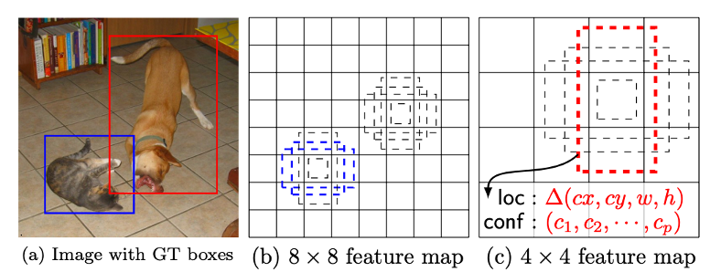

Figure 5. Single Shot MultiBox Detection (image obtained from the origin paper (Liu et al., 2015))

### Faster R-CNN

A competitor of the SSD family is the Faster Region-based Convolutional Neural Networks (Faster R-CNN), which was introduced also in 2015 (Ren et al., 2015). Unlike SSD models, R-CNNs are two-stage object detection algorithms that (1) produce region proposals that suggest the location of the objects based on which (2) boundary boxes and objectness scores are predicted. In Faster R-CNN architecture, the author introduced a Region Proposal Network (RPN) that address the model’s slow runtime issue which had been the bottleneck of any two-stage object detection networks.

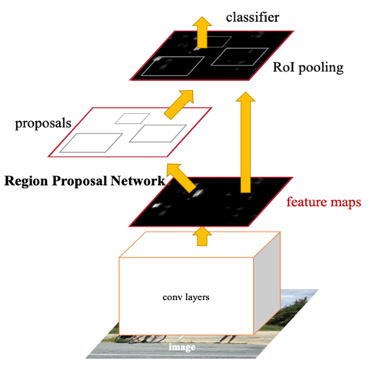

Figure 6. Faster R-CNN Mechanism (image obtained from the original paper (Ren et al., 2015))

### You Only Look Once (YOLO)

You Only Look Once (YOLO) was another framework that was introduced in 2015 (Redmon et al., 2015) whose one of the prominent features is that it is extremely fast. In YOLO architecture, an image is divided into an S x S grid, and on each grid cell the model predicts B bounding boxes (where each bounding box consists of 5 values, *x, y, w, h* and confidence) and the object class. With this mechanism the model sees the whole image once and therefore it is a single-stage object detection algorithm. Since the introduction of the original architecture, there has been much evolution of the YOLO family, resulting in YOLOv2 (Redmon & Farhadi, 2016), YOLOv3 (Redmon & Farhadi, 2018), YOLOv4 (Bochkovskiy et al., 2020), YOLOv5 (Ultralytics), YOLOv6 (Li et al., 2022), YOLOv7 (Wang et al., 2022), and most recently YOLOv8 (Ultralytics). This study used YOLOv5 for benchmarking and deployment.

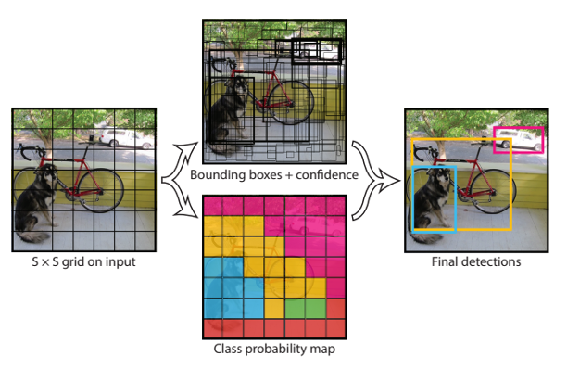

Figure 7. YOLO Mechanism (image obtained from the original paper (Redmon et al., 2015))

### Frameworks

To achieve high precision, the models were not built and trained from scratch but instead via transfer learning. Specifically, the models were downloaded with pretrained weights and thereby served as a starting point for fine-tuning. The pretrained models were obtained from two sources: the SSD and Faster R-CNN models were acquired from the TensorFlow2 Detection Model Zoo (TensorFlow) (Figure 8), while the pretrained YOLOv5 was obtained by cloning the model’s repository on GitHub (Ultralytics) (Figure 9).

On Figure 8, highlighted in red boxes are the chosen models from Model Zoo. They were, namely, *EfficientDet D1, SSD MobileNet FPNLite, SSD ResNet50 FPN (RetinaNet50),* and *Faster R-CNN ResNet50*. There are some points worth highlighting. First, all of the chosen models had similar training resolution of 640x640, and so does YOLOv5, to ensure fair benchmarking. Second, there were SSD and Faster R-CNN models of similar ResNet50 backbone so SSD can be compared against Faster R-CNN in this task. Third, since the project focused on not only experimenting but also deployment, the model list was extended to included SSD MobileNet and EfficientDet. On the one hand, MobileNet is a CNN developed by Google which were claimed to be suitable on mobile and embedded device (Howard et al., 2017). On the other hand, EfficientDet is an object detection network family which utilizes compound scaling method and weighted bi-directional feature pyramid network (BiFPN) to optimize model efficiency (Tan et al., 2019). Since these two models were claimed to be efficient in terms of speed and size, they were considered suitable candidates for deployment and hence were involved in this project.



Figure 8. TensorFlow Model Zoo. The chosen models are highlighted in red boxes.

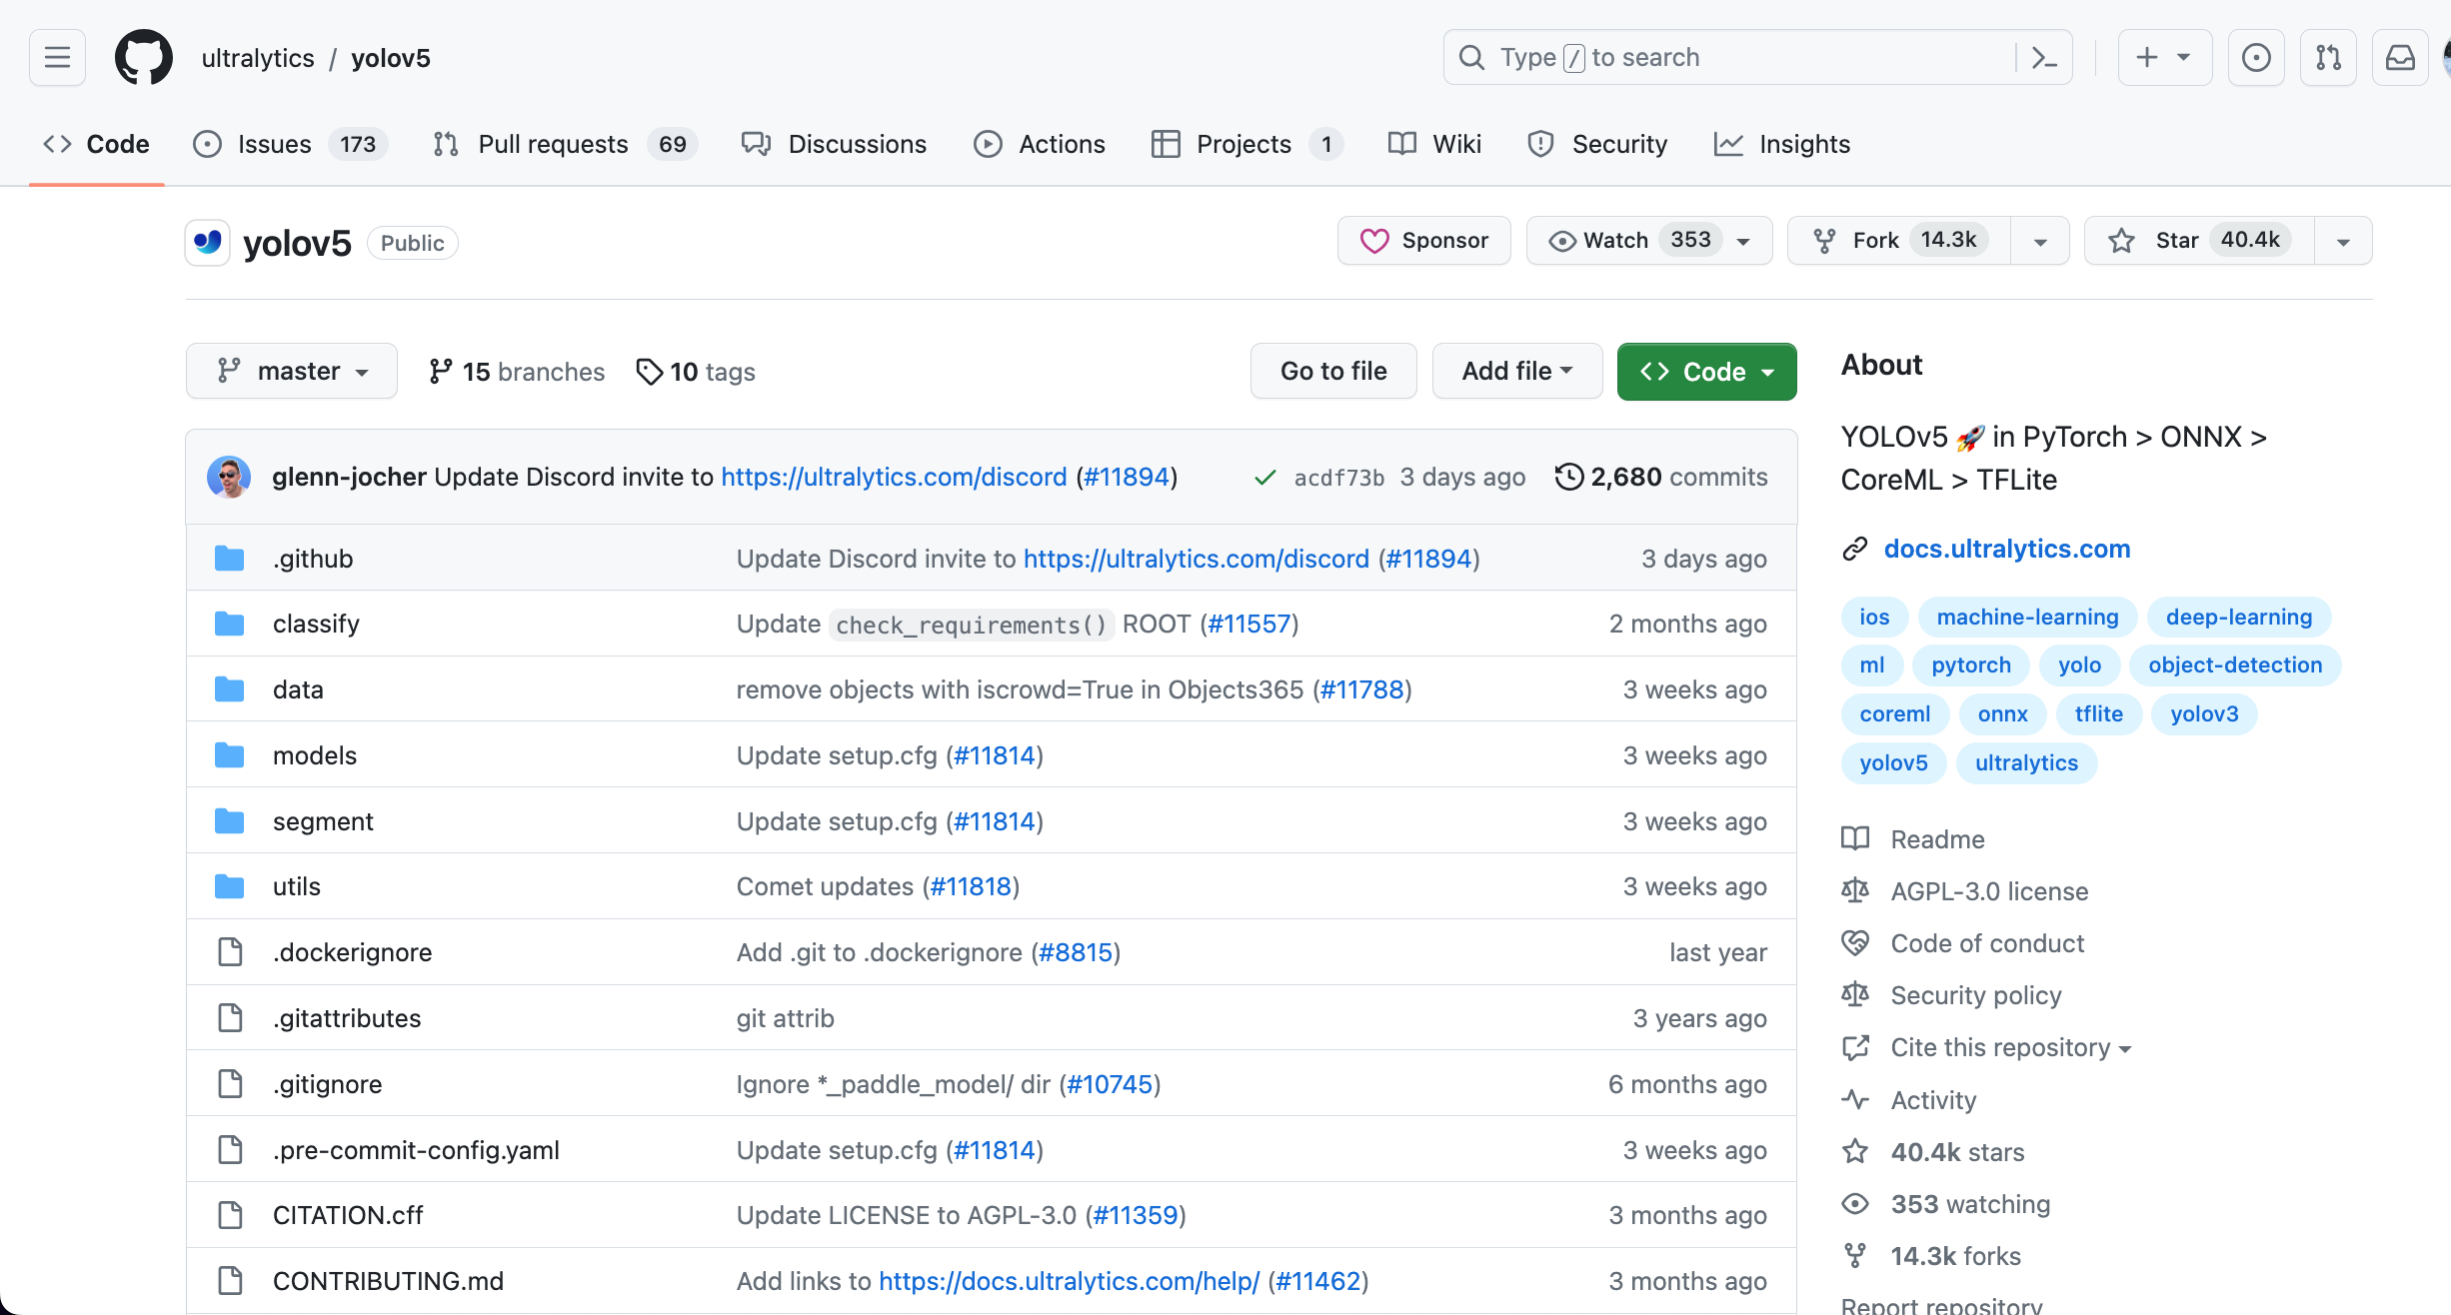

Figure 9. YOLOv5 GitHub Page

## Training and Evaluation

After the dataset and the models had been defined, model training was performed. Since there was no GPU available in any of the team members’ computers, the models were trained on Google Colab notebooks to utilize the free-of-charge GPUs that were provided by the service. To fit the training data to the GPUs, the training batch size was set to be 4, and in the TensorFlow framework the models were trained for 5000 training steps (Figure 10). The YOLOv5 framework required number of epochs instead of training steps to be specified, therefore, with the batch size of 4 and the number of training instances equal to 701, a calculation was done to convert 5000 training steps to the equivalent value of 29 epochs (Figure 11).

(a)

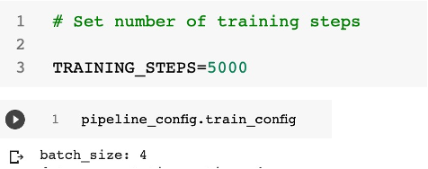

(b)

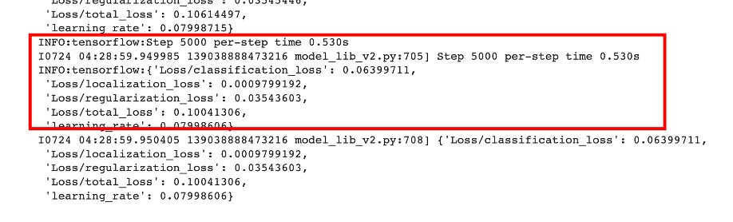

Figure 10. Snapshots of (a) Number of Training Steps and Batch Size, (b) Model Training at the last training step of TensorFlow Framework

(a)

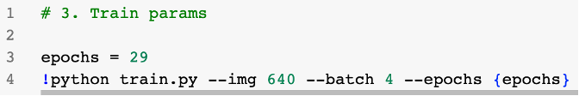

(b)



Figure 11. Snapshots of (a) Number of Epochs and Batch Size, (b) Model Training at the last epoch of the YOLOv5 Framework

Following model training was the model evaluation step which generated the precision scores as shown on Figure 12 and Figure 13. These precision values, together with other evaluation metrics of interest such as inference speed, model size and training time were collected and comprehensively presented in Section 3 of this report.

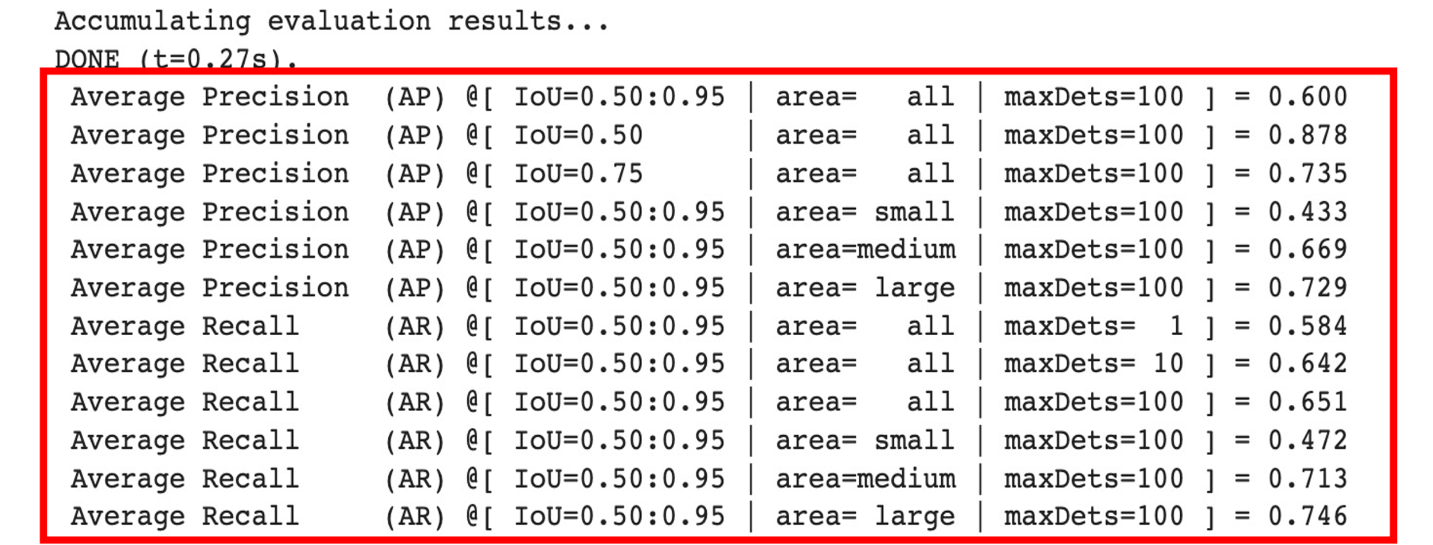

Figure 12. Snapshot of an Evaluation Results in the TensorFlow Framework

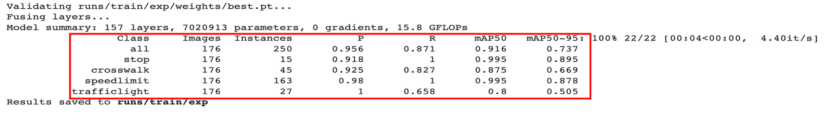

Figure 13. Snapshot of an Evaluation Results in the YOLOv5 Framework